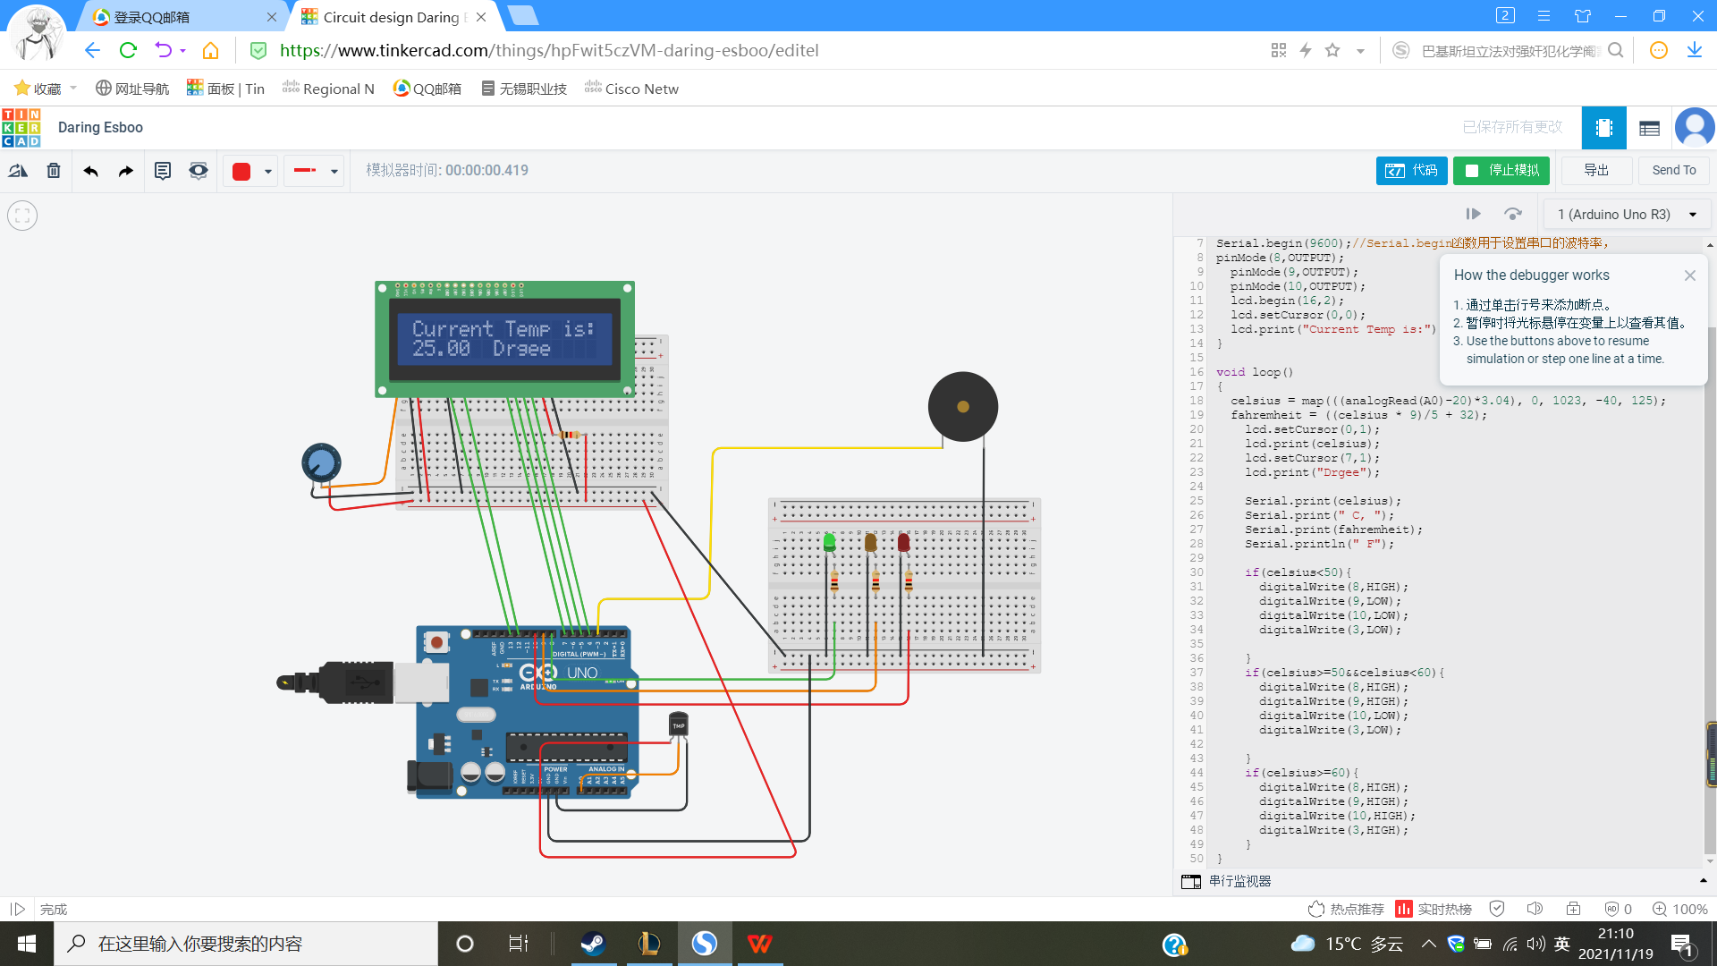
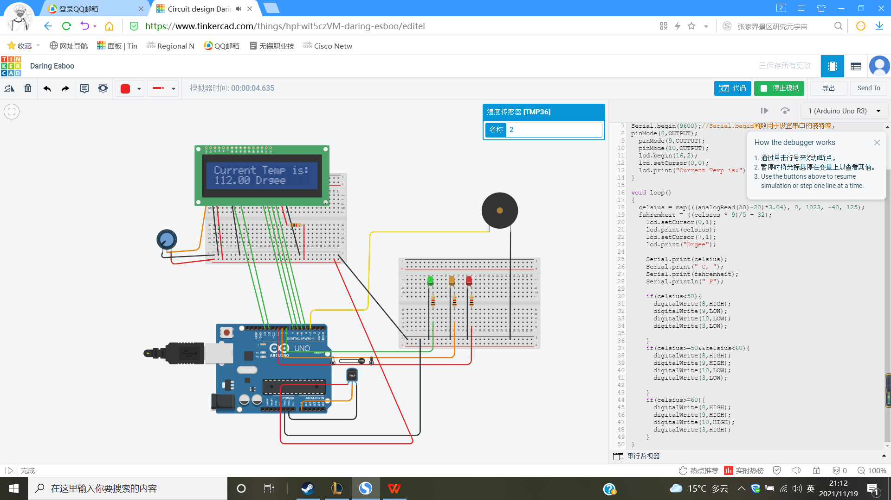
#include <LiquidCrystal.h>
LiquidCrystal lcd(13, 12, 7, 6, 5, 4);
float celsius = 0;
float fahremheit = 0;
void setup()
{
Serial.begin(9600);
pinMode(8,OUTPUT);
pinMode(9,OUTPUT);
pinMode(10,OUTPUT);
lcd.begin(16,2);
lcd.setCursor(0,0);
lcd.print("Current Temp is:");
}

1 void loop()
2 {
3 celsius = map(((analogRead(A0)-20)*3.04), 0, 1023, -40, 125);
4 fahremheit = ((celsius * 9)/5 + 32);
5 lcd.setCursor(0,1);
6 lcd.print(celsius);
7 lcd.setCursor(7,1);
8 lcd.print("Drgee");
9
10 Serial.print(celsius);
11 Serial.print(" C, ");
12 Serial.print(fahremheit);
13 Serial.println(" F");
14
15 if(celsius<50){
16 digitalWrite(8,HIGH);
17 digitalWrite(9,LOW);
18 digitalWrite(10,LOW);
19 digitalWrite(3,LOW);
20
21 }
22 if(celsius>=50&&celsius<60){
23 digitalWrite(8,HIGH);
24 digitalWrite(9,HIGH);
25 digitalWrite(10,LOW);
26 digitalWrite(3,LOW);
27
28 }
29 if(celsius>=60){
30 digitalWrite(8,HIGH);
31 digitalWrite(9,HIGH);
32 digitalWrite(10,HIGH);
33 digitalWrite(3,HIGH);
34 }
35 }

